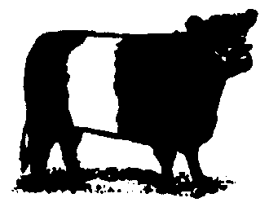

BELTED GALLOWAY CATTLE SOCIETY

Secretary Ian J.R. Sutherland
Rock Midstead, Alnwick, Northumberland, NE66 2TH

Tel. 07891 245870 Fax 01665 579326
Email info@beltedgalloways.co.uk www.beltedgalloways.co.uk

AUTUMN
2011

ANNUAL GENERAL MEETING
Autumn is here again – it seems to come round quicker every year – and it’s a very busy time in the Belted Galloway calendar. October 20th sees the Society’s annual general meeting and annual dinner, and the following day is the premier show and sale of Belties to be held at Wallets Marts, Castle Douglas. Members will receive various papers with this newsletter, and they are encouraged to take part in the process by nominating new Council members as well as a new President and Vice Presidents. Once again the A.G.M. and dinner will be held at the Urr Valley Hotel in Castle Douglas. Members are invited to nominate up to five new Council members using the accompanying form, together with replacements for our retiring President and Vice President (see below). A booking form is also provided for dinner tickets, and members are advised to return this as soon as possible, as the dinner is a popular event is often over-subscribed. Tickets will be allocated on a first come first served basis.
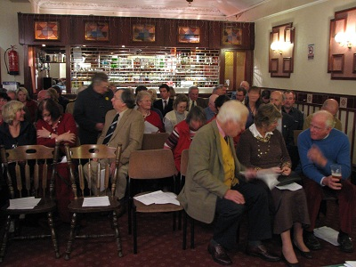

n

ew

s

l

e

t

t

e

r

+

++++N
E
W
S
L
E
T
T
E
R
A well-attended A.G.M. at the Urr Valley hotel 2010
Helen Hamilton (left) with her record breaking bull Aztec Lullenden Warrior and the proud new owner Beltie Council member Tim Oliver (right)
PRESIDENT AND VICE PRESIDENT RETIRE
Two of the most well-known figures in the Belted Galloway Society are stepping down from their posts this year after a lifetime of sterling service to the breed and to the Society. Both are associated with some of the most significant herds in the history of Belted Galloways. Although President John Rutherford is retired from cattle farming the Burnside herd is remembered as an important source of stock bulls and names such as Burnside David appear on many of today’s pedigrees. John has served the Society faithfully as a Council member and as Secretary, and during his time as President he has seen through changes which will ensure the future of the Society for many years to come. Helen Hamilton’s Lullenden herd stretches back to the birth of the Society itself, and her contribution to the breed over the decades was recently crowned when she achieved an all time record price for a Belted Galloway sold at auction with her bull Lullenden Aztec Warrior which sold at Castle Douglas in 2010 for 7,500 guineas. Council is very keen to show the appreciation of the Society to both John and Helen, and has decided to confer the special attribute of Honorary Life President on both of them. Nomination forms are included with this mailing to allow members to nominate successors if they wish. Council has already agreed to nominate past chairman Robert Graham for the position of President.
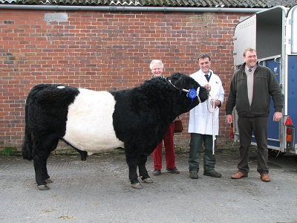
CATTLE HEALTH SCHEMES
There are currently a variety of health schemes run by institutions such as the Scottish Agricultural Colleges, and some breed societies actively encourage their members to join up in the interests of improved animal health. Breeders will be aware that Scottish Government recently announced an initiative to eradicate Bovine Viral Diahorrea from the national herd, and the Society already receives enquiries from breeders looking to source high health status cattle. Council has discussed animal health at its last meeting, and views from members on the subject would be welcome so that a wider debate may get underway.

A.G.M.
Urr Valley Hotel, Castle Douglas
20th October 2011
At 6.30 p.m.
ANNUAL DINNER
Urr Valley Hotel
20th October 2011
7.30 p.m. for 8.00 p.m.
Tickets £22 from Secretary
PRE-SALE SHOW
Wallets Marts, Castle Douglas
21st October 2011
At 9.30 a.m.
ANNUAL SALE
Wallets Marts, Castle Douglas
21st October 2011
At 11.00 a.m.
CHANGES TO THE REGISTRATION RULES FOR WHITE GALLOWAYS

For some time anomalies have been apparent in the rules for registering White Galloways which have caused problems from time to time. In particular the appendix system meant that some animals would never achieve full registration because the necessity to cross some black Galloway blood into the herd resulted in having to “go back to square one” every time. Council has given this careful consideration and decided to streamline the system so that bona fide White Galloways can become fully registered more easily. In addition the issue of solid black or red calves being produced from registered white parents has been addressed so that these cattle are no longer excluded from the system. Having decided on these changes Council is mindful that they cannot be implemented too quickly and will set a timetable which will give breeders ample time to adjust. The existing rules will continue into the new year and will be printed in the 2012 edition of the Annual News as usual. The new rules will also appear in the News, however these will not come into force until much later. This will give breeders time to make any necessary adjustments to their plans. For information only the new rules will be as follows:-
- Solid black or red females born to registered White parents, while not eligible for registration themselves, could have eligible daughters admitted to the foundation appendix provided the solid dam had been birth notified. The same would apply to daughters of cattle which were ineligible due to poor markings.
- The existing clause in the registration rules which states that “Bulls can only be registered from fully registered females and sired by a registered White Galloway bull or a pedigree Black or Red Galloway bull” will be altered to also allow bulls to be registered from fully registered White females or pedigree Black or Red Galloway females which have been mated with a registered White Galloway bull (i.e. the other way round).
- The definition of Foundation females to be altered to read:-
“Foundation females must be of White Galloway type. If mated to a pedigree black or red Galloway bull, or a registered White Galloway bull, the resulting female calves may be eligible for appendix A if they are of correct White Galloway type and have black or red points to the ears and feet, and not too much flecking on the body”.
- The definition of appendix A females to be altered to read:-
Appendix A females must be of White Galloway type and must have black or red points to the ears and feet, with not too much flecking on the body. If mated to a registered White Galloway bull resulting female calves, provided they are of White Galloway type with black or red points to the ears and feet and not too much flecking on the body, will be eligible for full registration”.
- Appendix B to be abolished.
- Bull inspectors should have sight of registration records if sired by a White Galloway bull and pedigrees if sired by a black or red Galloway bull.

ANNUAL NEWS 2012
We are already turning our attention to next year’s edition, and articles and information for inclusion in the magazine are invited now. The News is truly the members’ magazine, with most of the articles reflecting their views and experience of keeping Belties and White Galloways. Please send any interesting items as well as photographs to the Secretary, preferably by November 30th, so that we can get it published as soon as possible in the new year. This year we are hoping to make” Beltie beef” a theme in the News, so we are particularly interested in features from members who have any experience in marketing Beltie beef in any form. Adverts are also welcome, and are a great way of publicising your herd among members. Adverts for Beltie art and other merchandise are also welcome. The News is a quality full colour publication and is sent out to over 600 members and friends all over the world. Please let any of your friends know about it and let us have your contributions as soon as possible. Material can be sent in any medium, although email attachment is preferable. Adverts have been held at £100 per full colour page; £60 per half colour page; £60 per full black and white page and £40 per half black and white page.
WORLD GALLOWAY CONFERENCE 2012
Plans are already well underway for the next bi-annual conference, which is being hosted by the Canadian Galloway Association and will take place in Guelph, Ontario, provisionally from 3rd to 7th October 2012. A very interesting programme of visits to Galloway and Beltie herds has been laid on as well as some impressive sights, including local shows, the world’s second largest Oktoberfest and, of course, Niagra Falls. Accommodation will be at the Holiday Inn, Guelph and the trip is expected to cost in the region of $350 per person, not including travel to and from the conference. If past conferences are anything to go by this will be an excellent chance to meet like-minded breeders from all parts of the world and to spend a few days enjoying fascinating visits and glorious scenery. All interested parties are welcome to take part, so if you would like to come along please contact the Secretary who will keep you informed as things develop.

