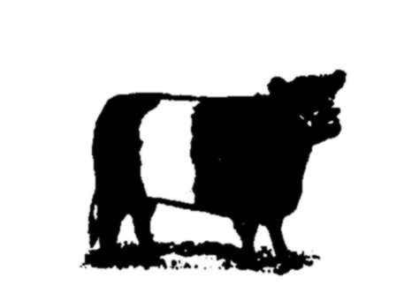

THE BELTED GALLOWAY CATTLE SOCIETY
OXNAM NEUK FARMHOUSE, JEDBURGH, SCOTTISH BORDERS. TD8 6RE
Tel. 01896 820148 / 07891 245870 Email info@beltedgalloways.co.uk
Company no. SC012107 V.A.T. reg. no. 993 12145 06 Charity no. SC028218

MEMBERSHIP APPLICATION FORM

Please tick as required (fees are inclusive of V.A.T.):-
Life Membership - £720 .............................[ ] Annual Membership - £36.00 ..........................................[ ]
Associate Annual Membership - £24.00......[ ] Joining fee Full Member - £36.00 ....................................[ ]
Junior Annual Membership - £12.00……...[ ]
Please Print:-
Name ............................................................................................ Tel. No. ....................................................
Address ............................................................................................. Mobile .....................................................
............................................................................................................. Herd Prefix .............................................. (should be one word)
............................................................................................................. Date of birth (Junior Member) ………….
.............................................................................................................. Ear Tag Herd No ......................................
Post Code .................................... Email .................................................................................................................
Signature ............................................................................................ Date .........................................................
Note:- Full Membership and a herd prefix are necessary for those wishing to register cattle. Associate Membership may be taken by anyone else. Please enclose payment with this form. If you wish to pay your annual subscription by standing order please hand the mandate form below to your bank. Subscriptions are due on 1st January every year, so your standing order should be paid on that date.
DATA PROTECTION:- The Society is bound by Data Protection legislation and must obtain your permission before publishing your details.
Please include my details in lists displayed in the Society’s website and other publications:-
Signed............................................................................................. Print name..........................................................................................

STANDING ORDER MANDATE FORM
Member’s details:-

Bank ........................................................................... Sort code ..................................................

Branch ................................................................. Address ....................................................................

.................................................................................................................................................................

Account name ...................................................................... Account number .......................................

Member’s telephone number ....................................................................................................................
Society’s details:-
Account name Belted Galloway Cattle Society Ltd.
Account number: 00115676 Sort Code: 80 06 11
Bank: Lloyds Bank

The payment:-
Full membership £36.00 Associate membership £24.00 (Please delete as appropriate)
Date of payment 1st January Frequency Annually (until further notice)

Confirmation:-
I/we acknowledge that the Bank will not undertake to:-
- Make any reference to V.A.T. or other indeterminate element
- Advise payee’s address to beneficiary
- Advise beneficiary of inability to pay
- Request beneficiary’s banker to advise of receipt

Member’s signature:- .................................................................................... Date ......................................

