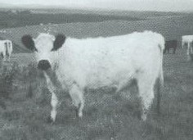
THE BELTED GALLOWAY CATTLE SOCIETY
OXNAM NEUK FARMHOUSE, JEDBURGH, SCOTTISH BORDERS. TD8 6RE
Tel. 07891 245870 Email info@beltedgalloways.co.uk

WHITE SECTION REGISTRATION FORM

HERD BOOK ENTRY FORM
(Office use only)

DETAILS OF CALF

Name
Day Month Year
Sex Colour of points

Date of birth

Ear Tag
Number

......................................................................... Birth Notification Number BN.........................

PEDIGREE

SIRE. H.B. No....

Sire of Sire................................................................................................ H.B. No..................................

Dam of Sire............................................................................................... H.B. No..................................

DAM........................................................................................................ H.B. No..................................

Sire of Dam............................................................................................... H.B. No..................................

Dam of Dam.............................................................................................. H.B. No..................................

MARKINGS

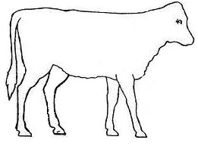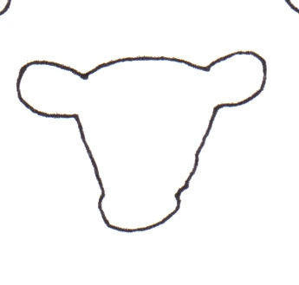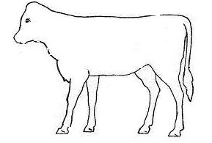
BREEDERS CERTIFICATE : I certify that the above particulars are correct.

Signature. ............... Date ........

Name (Print) ........................................................... Address ... ........

.................................................................................................... Tel:......................................................

PLEASE ENCLOSE THE APPROPRIATE FEE, IF NO FEE IS ENCLOSED AN INVOICE WILL BE RAISED, HOWEVER THE REGISTRATION WILL NOT BE PROCESSED UNTIL PAYMENT IS RECEIVED.
Registration fee : £24.00 up to 12 months of age £48.00 over 12 months of age

